Review the Gaussian Mixture Model (GMM) clustering algorithm using expectation-maximization

For ODD T-number use K = 2 and for even T-number use K = 3 in general

1. For k number of clusters, plot the sum of log likelihoods vs epochs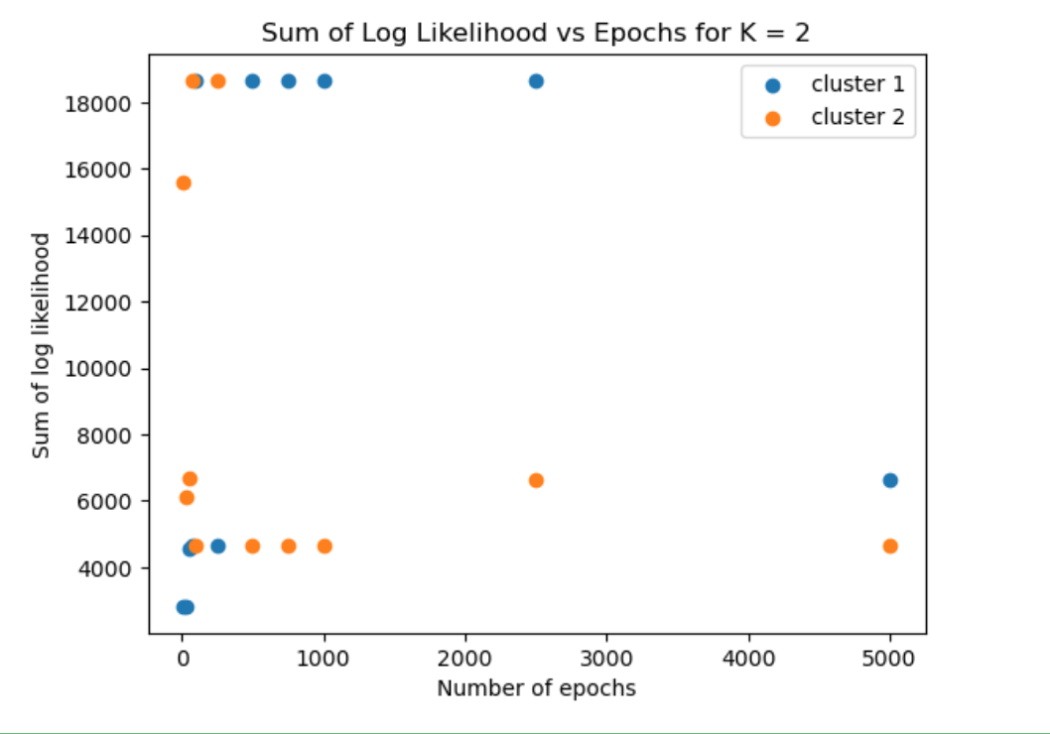Chart, scatter chart

   Description automatically generated
2. Print the size of likelihood variable, posterior variable, prior variable, and totals variable

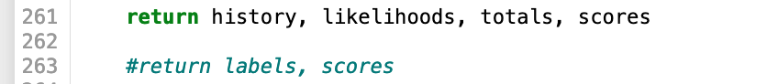

(First, I modified the return variables in the fit_predict_gmm function)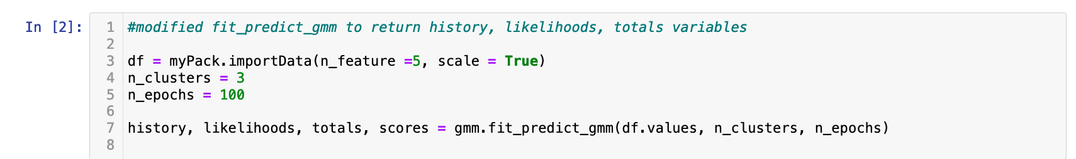

1. Fill in the table below

|  |  |  |  |  |  |
| --- | --- | --- | --- | --- | --- |
| Sample ID | Totals | Cluster 1 score | Cluster 2 score | Cluster 3 score | Decision |
| 1 | 1.52872790e-04 | 3.93802235e+01 | 1.96234397e-01 | 1.73519197e+00 | 1 |
| 2 | 8.63562854e-05 | 4.39375975e+01 | 6.59835547e-01 | 7.33544102e-01 | 1 |
| 3 | 6.77810067e-05 | 1.30775991e+01 | 2.24245975e-01 | 1.69372764e+00 | 1 |

1. Fill in the table below

|  |  |  |  |
| --- | --- | --- | --- |
| Cluster/Parameters | Mean | Sigma | Importance (Wk) |
| Cluster 1 | -0.63637735 | 2.15145862e-01 | 1 |
| Cluster 2 | 1.36632125e-01 | 0.36733948 | 1 |
| Cluster 3 | 0.6148613 | 0.10836499 | 1 |